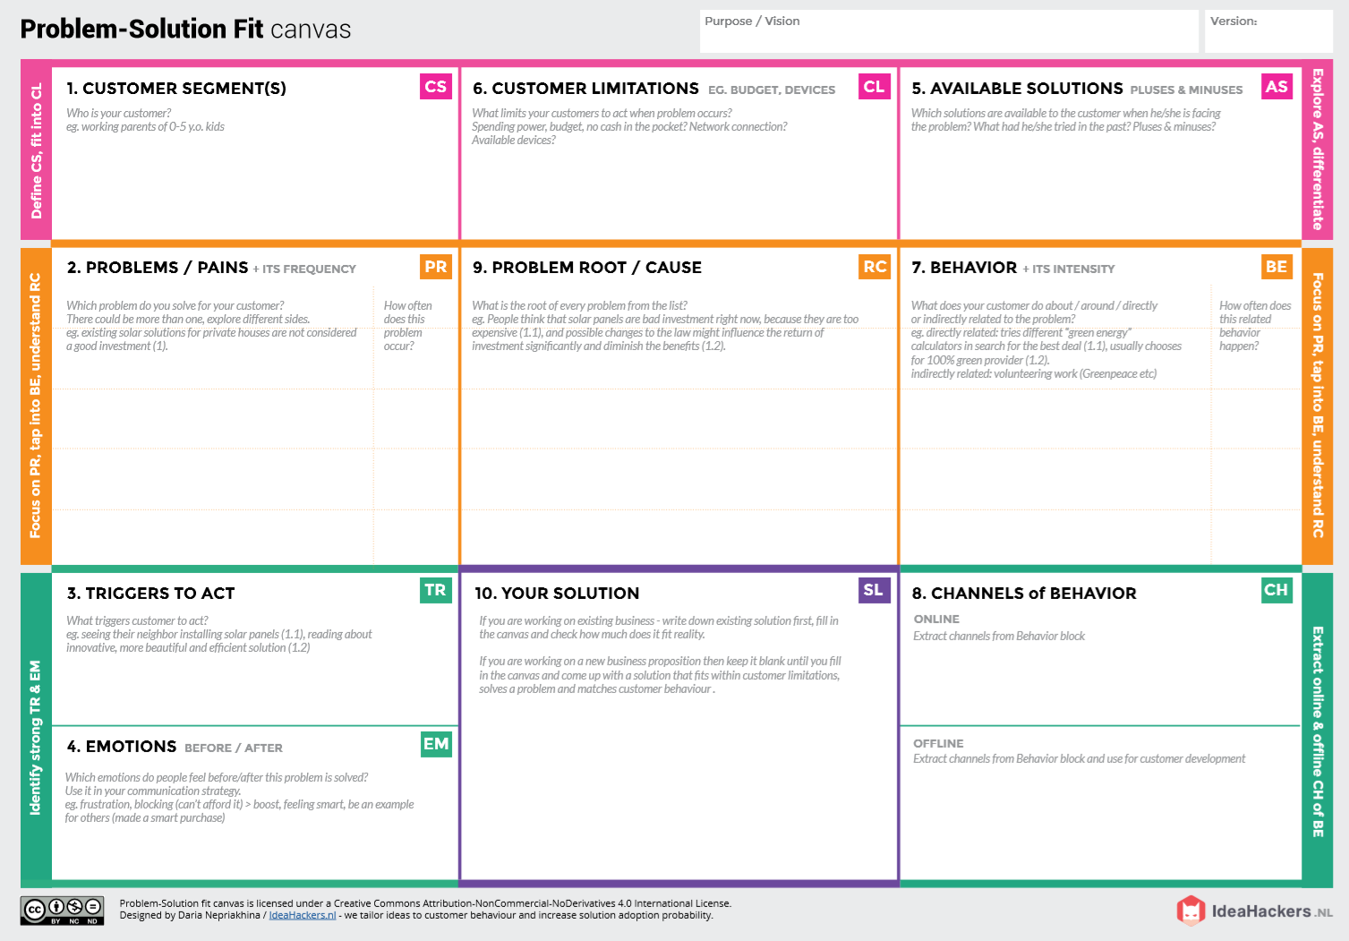**Project** : **IOT BASED SMART CROP PROTECTION SYSTEM FOR AGRICULTURE**

**OFFLINE: The control action is taken by the farmers to monitor the farms.**

**ONLINE: The Data send through application for the farmers to know about the farms.**

**Direct related: Tries to find a solution to prevent this problem**

**Indirect related: Located in rural where internet connectivity might not be strong enough to facilitate fast transmission speeds.**

**Using this IOT based smart protection system we can save farm from the damage.**

***“IOT BASED SMART CROP PROTECTION SYSTEM FOR AGRICULTURE” !!***

**It help farmers grow more food on less land. By the help of protecting crops from pests, diseases and weeds as well as raising productivity per hectare.**

**Farmer affected by less productivity when the temperature, PH level, humidity and light intensity makes the serious cause for the environment.**

**1)High adoption costs , security concerns. 2)Not aware of the implementation of IOT in agriculture.**

**When the farmer’s are not near the farm.**

**Giving chance to lift people out of poverty in developing nations.**

**Project Design Phase – 1**

**SOLUTION FIT**

**Team ID: PNT2022TMID26844**

**BEFORE: Finances, Heavy work overload and conflict in relationship.**

**AFTER: It will easier to make more yield in field**

1. **It’s difficult to monitor and control**
2. **Aren’t known if the application doesn’t work properly.**